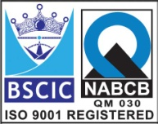****

**“EASCO” Duel Plate Check Valve Flanged ASA150#**

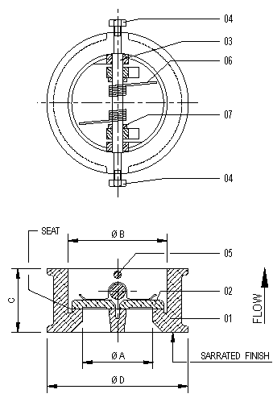

**Technical Data-**

* Manufacturing Std: API 594
* Testing & Inspection Std: API 598

**Testing Standard: - API 598**

|  |  |  |
| --- | --- | --- |
| Test Pressure in BAR | | |
| Test | Hydrostatic | Air |
| Pr. Rating | ASA125# |
| Body | 25 |  |
| Seat | 16 | - |

**Part Name:- ASA150:-**

|  |  |  |  |  |  |  |  |  |
| --- | --- | --- | --- | --- | --- | --- | --- | --- |
| **No.** | **Part Name** | **Material** |  | **Size** | **A** | **B** | **C** | **D** |
| **01** | **Body** | **CI – IS:210 Gr. FG 200** | **50** | **50** | **60** | **60** | **105** |
| **02** | **Disc** | **A351 Gr. CF8** | **65** | **65** | **75** | **67** | **124** |
| **03** | **Hinge Pin** | **AISI 304** | **80** | **76** | **90** | **73** | **134** |
| **04** | **Plug** | **AISI 304** | **100** | **100** | **115** | **73** | **172** |
| **05** | **Stop Pin** | **AISI 304** | **125** | **125** | **135** | **83** | **196** |
| **06** | **Spring** | **AISI 304** |  | **150** | **150** | **165** | **98** | **220** |
| **07** | **Bearing** | **AISI 304** |  | **200** | **200** | **220** | **127** | **276** |
|  |  |  |  | **250** | **250** | **265** | **146** | **338** |
|  |  |  |  | **300** | **300** | **320** | **181** | **407** |
|  |  |  |  | **350** | **350** | **350** | **184** | **448** |
|  |  |  |  | **400** | **400** | **400** | **191** | **514** |
|  |  |  |  | **450** | **450** | **450** | **203** | **549** |
|  |  |  |  | **500** | **500** | **500** | **219** | **603** |
|  |  |  |  | **600** | **600** | **600** | **222** | **718** |

**Due to continuous development Program, the design & data given in this leaflet are subject to change without prior notice.**

**ANITA ENGINEERING WORKS**



58-59, Narayan Estate, Opp. Shree Ram Estate, Nr. CMC Ltd. Odhav, Ahmedabad-382415, Gujarat, India

Phone: +91 79 22974101, Fax: +91 79 22875014

Email: eascovalves@gmail.com, eascovalves@yahoo.com, Web: [www.eascovalve.com](http://www.eascovalve.com)